Data Frame in Python
Assignment

- Which attribute of dataframe is used for the following –
  - To display row labels –
  - To Display column labels –
  - To display data types of all columns in the Data Frame
  - To display all the values in the Data Frame
  - To display number of rows and columns in a data frame
  - To display total number of values in data frame
  - To transpose the data frame
  - To returns the value True if DataFrame is empty and False otherwise
- Write a statement in python to add a new column “Marks” with the values (23,34,45,12) in a DataFrame “DF”
- Cerate a DataFrame given in following figure-

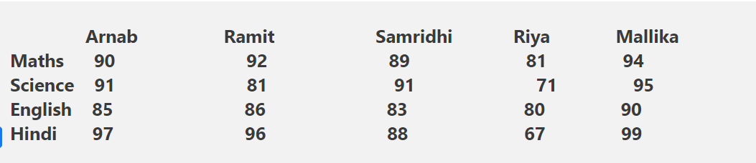
  - Write a command to find the records having marks more than 90 in Maths.
  - Display the records of all students only for maths and English
  - Display the records for Arnab, Ramit, Riya
  - Write a command to display marks of ‘Riya’

- Dhriti is working in a company where she was asked to create the following dataframe. Help her in writing the code to create the dataframe ‘df’ with ‘W1’,’W2’,’W3’,’W4’ index value and also write the answers of the following task.
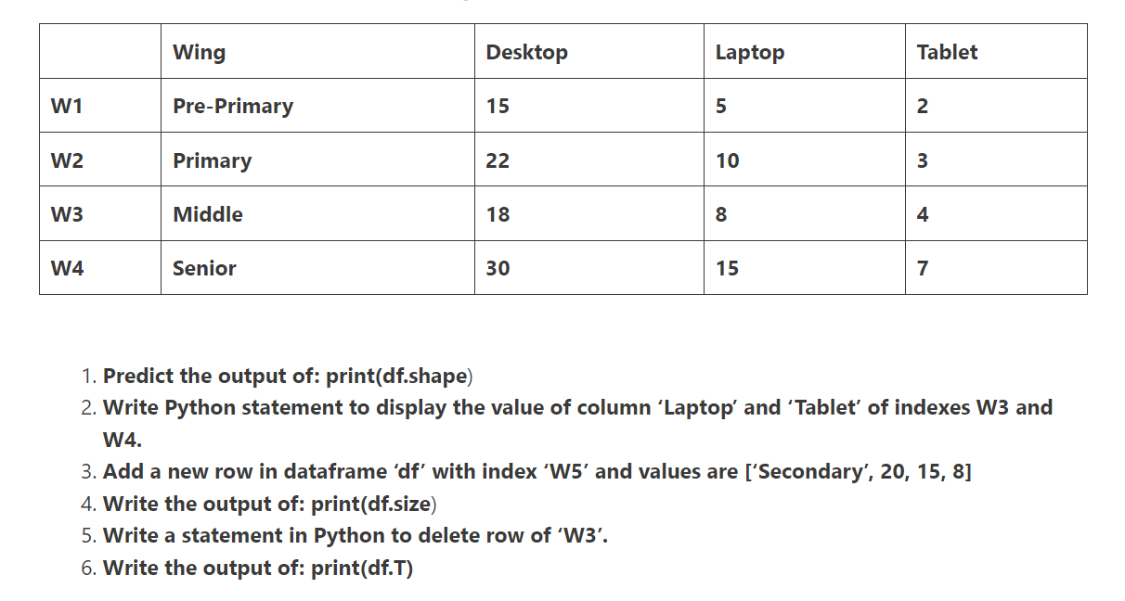
- Consider the following dataframe ‘DF’ and answer the following questions
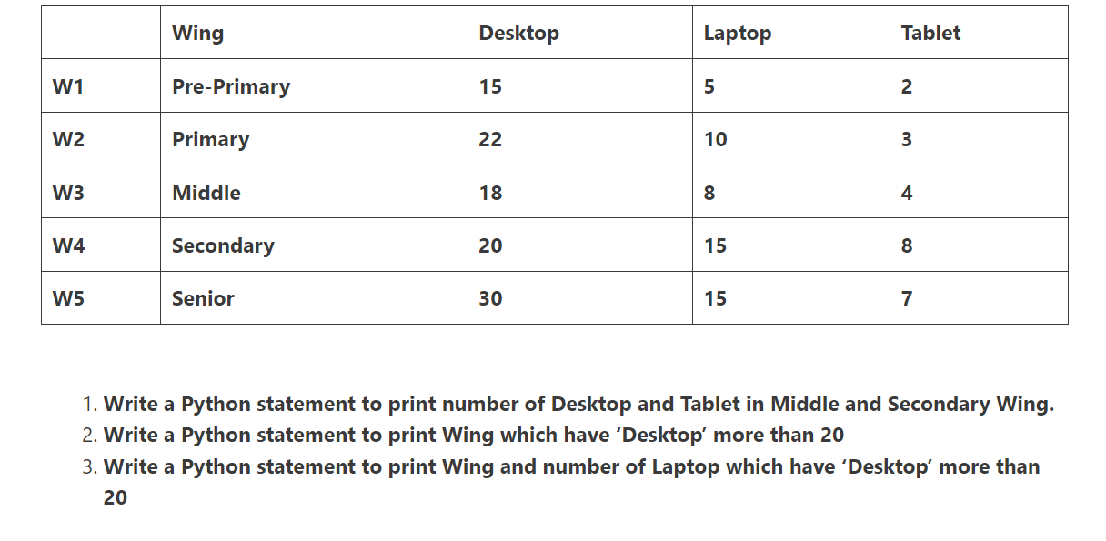

- Consider the following dataframe
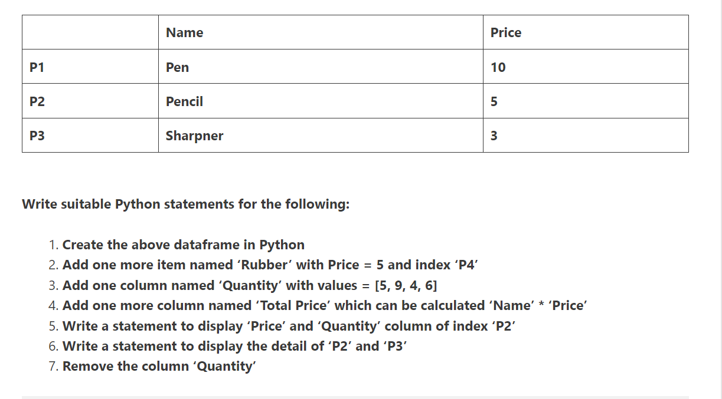

- Write a program to create a DataFrame from a list containing dictionaries which contains “Salaries” and “Incentives” for 4 employees. Employee names should be the row labels. Change the index as ‘Raj’,’Aman’,’Rahul’,’Darpan’

- Write code to create DataFrame from a list containing 4 dictionaries, where each dictionary containing Target and Actual Sales figures of four zonal offices. Give appropriate row labels. Change the indexes as –‘Zone 1’,’Zone 2’,’Zone 3’,’Zone 4’

